NETWORKING & SYSTEM ADMINISTRATION LAB

Experiment No.: 14

Aim:
Write a shell scripting program to display current date and calender(month).
Procedure:
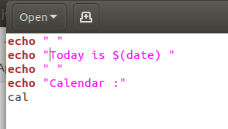

Output Screenshot:
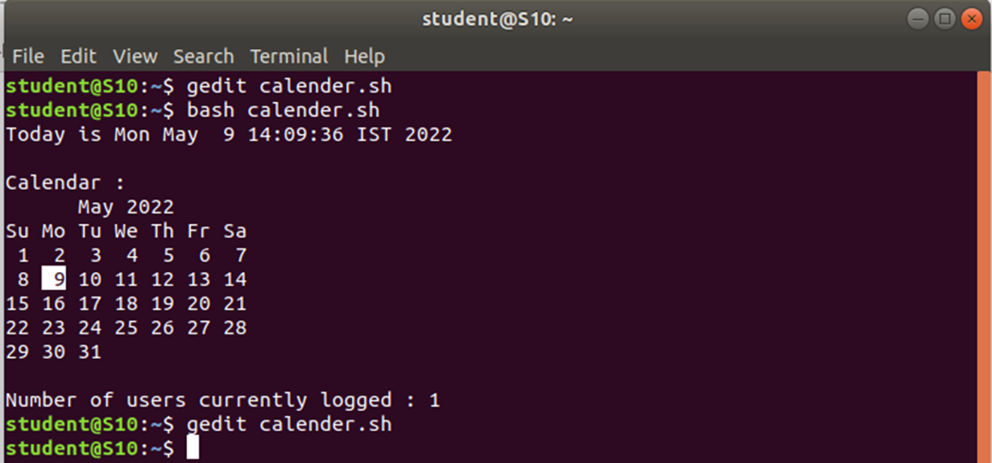

Experiment No.: 15

Aim:
Write a shell scripting program to check whether two numbers are greater,lesser or equal to each other.
Procedure:
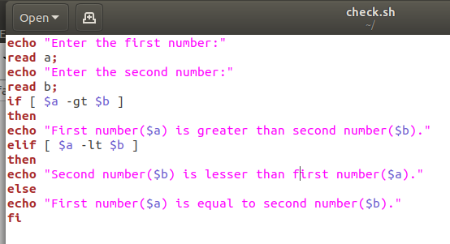

Output Screenshot:

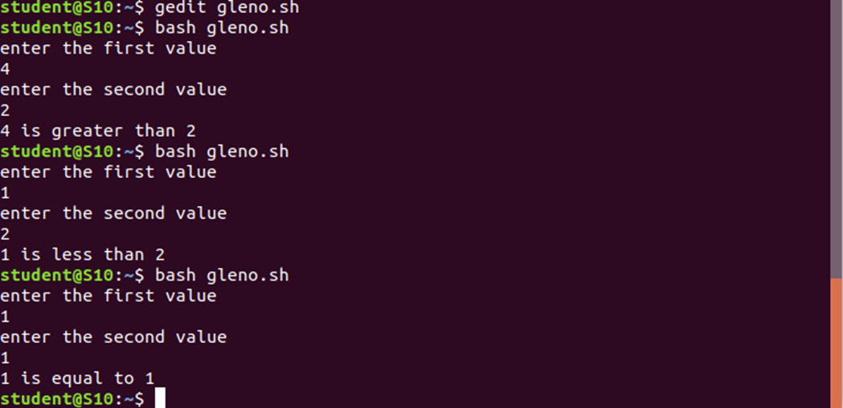

Experiment No.: 16

Aim:
Write a shell scripting program to find the sum of given ten numbers.

Procedure:
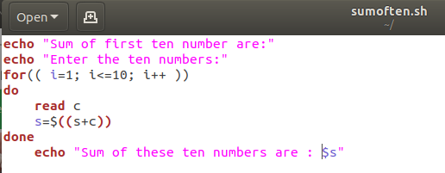

Output Screenshot:
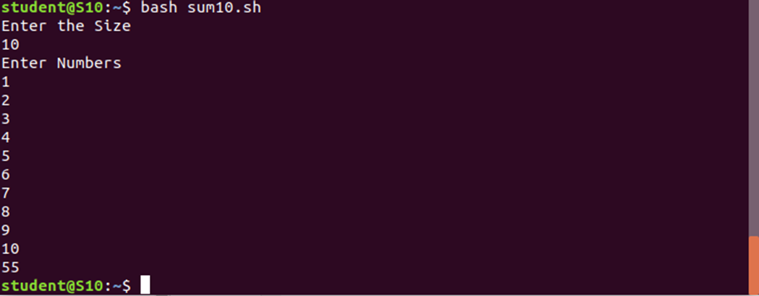

Experiment No.: 17

Aim:
Write a shell scripting program to find the sum, product and average of given four numbers.

Procedure:
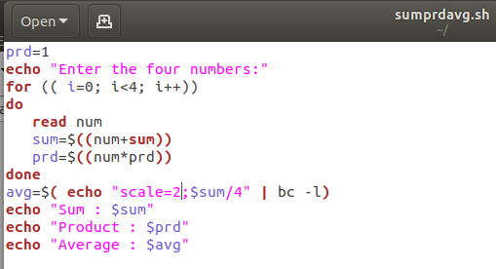

Output Screenshot:
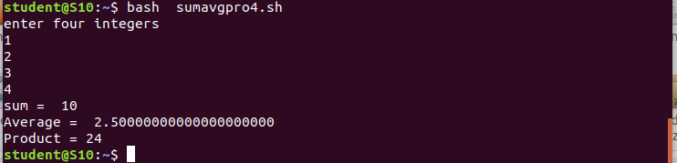

Experiment No.: 18

Aim:
Write a program to find the factorial of a number.

Procedure:

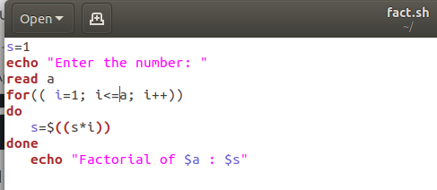

Output Screenshot:
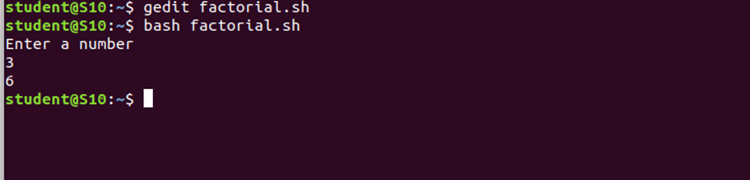

Experiment No.: 19

Aim:
Write a shell scripting program to find whether a number is pallidrome or not.
Procedure:
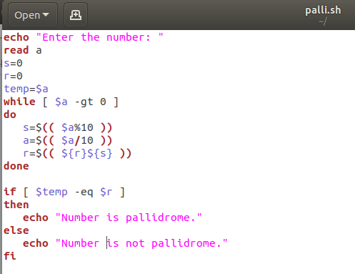

Output Screenshot:
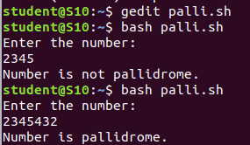

Experiment No.: 20

Aim
Check whether a year is leap year or not.

Procedure
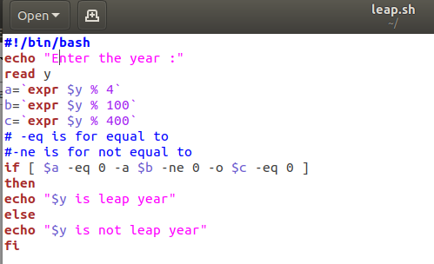

Output Screenshot
